
Give a gift in someone’s honor to Mission at the Eastward – South Africa Partnership to help with Home Gardens in the Tyhume Valley of South Africa.

Presbyterian Church (usa)

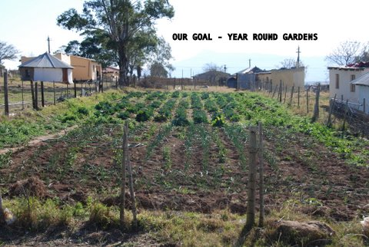
An Exceptional Family Garden in the Tyhume Valley – South Africa.
Most lack adequate fencing to keep out the animals. Even this fencing is too low to keep out some goats, and too weak to keep out hungry cattle.
Our goal: Help the grannies feed themselves and their orphaned grandchildren with improved family gardens and village communal gardens.

MATE-SAP, P.O. Box 206, Farmington, ME 04938.
207-778-4705. Email: mate@beeline-online.net,
Website: www.missionattheeastward.org or www.southafricapartnership.weebly.com

Alternative Gift Giving:

During the Christmas Season, giving of gifts is an expression of love and joy for the greatest gift given to mankind – Jesus Christ.

If you have a special person in your life who would appreciate a gift given in their honor, or if there is someone you would like to remember with a memorial gift, please consider our work in South Africa as a worthy recipient. The focus of our effort is AIDS orphans, the grannies who care for them, and other ‘innocent’ victims of the AIDS pandemic.

MATE-SAP is a ministry of the Presbyterian Church USA, and the donations are used 100% for the Home Gardens in the villages of Sompondo, Kwezana, Mazotsho, Majwareni, Upper Ncera [Lalini & Sigingqini], Krwakrwa, Dyamala, Jonini and Francis in the Tyhume Valley of the Eastern Cape Province of South Africa.

Presbyterian Church (usa)
The Presbyterian Church (USA) is recognized as a non-profit 501(c)(3) charitable organization. All gifts are tax-deductible to the fullest extent allowed by law.

I am giving a gift in honor of:
Name: ___________________________________________________
Address: _________________________________________________
__________________________________________________________

My name and address:
Name: ___________________________________________________
Address: _________________________________________________
__________________________________________________________
Email: ____________________________________________________

Home Garden Fencing Needs-Charitable Contribution
Droppers [stabilizers} | $2
1.8 meter mid-poles | $5
2.3 meter corner poles | $8
Amagaba [hoe] | $15
Hose Pipe [water hose] | $20
25 kg barbed wire | $60
30 meters – net wire | $180
1 garden – 10m x 20m | $900
Hiring natural farming consultant – 1 day | $250

The chart above represents the type of items the village committees can purchase with the funds they receive. Please mail your donation to MATE-SAP at the address shown to the left, payable to MATE-SAP. If you fill in the honoree information above, [or include all relevant information on a separate sheet] MATE-SAP will send a note to them on your behalf, and we will send you a receipt. If you have any questions – please call or email the MATE office as shown to the left.

MATE – South Africa Partnership
Below is the communal garden in the village of Mazotsho – which is on the southern shore of the Binfield Dam – the water supply for the Tyhume Valley.
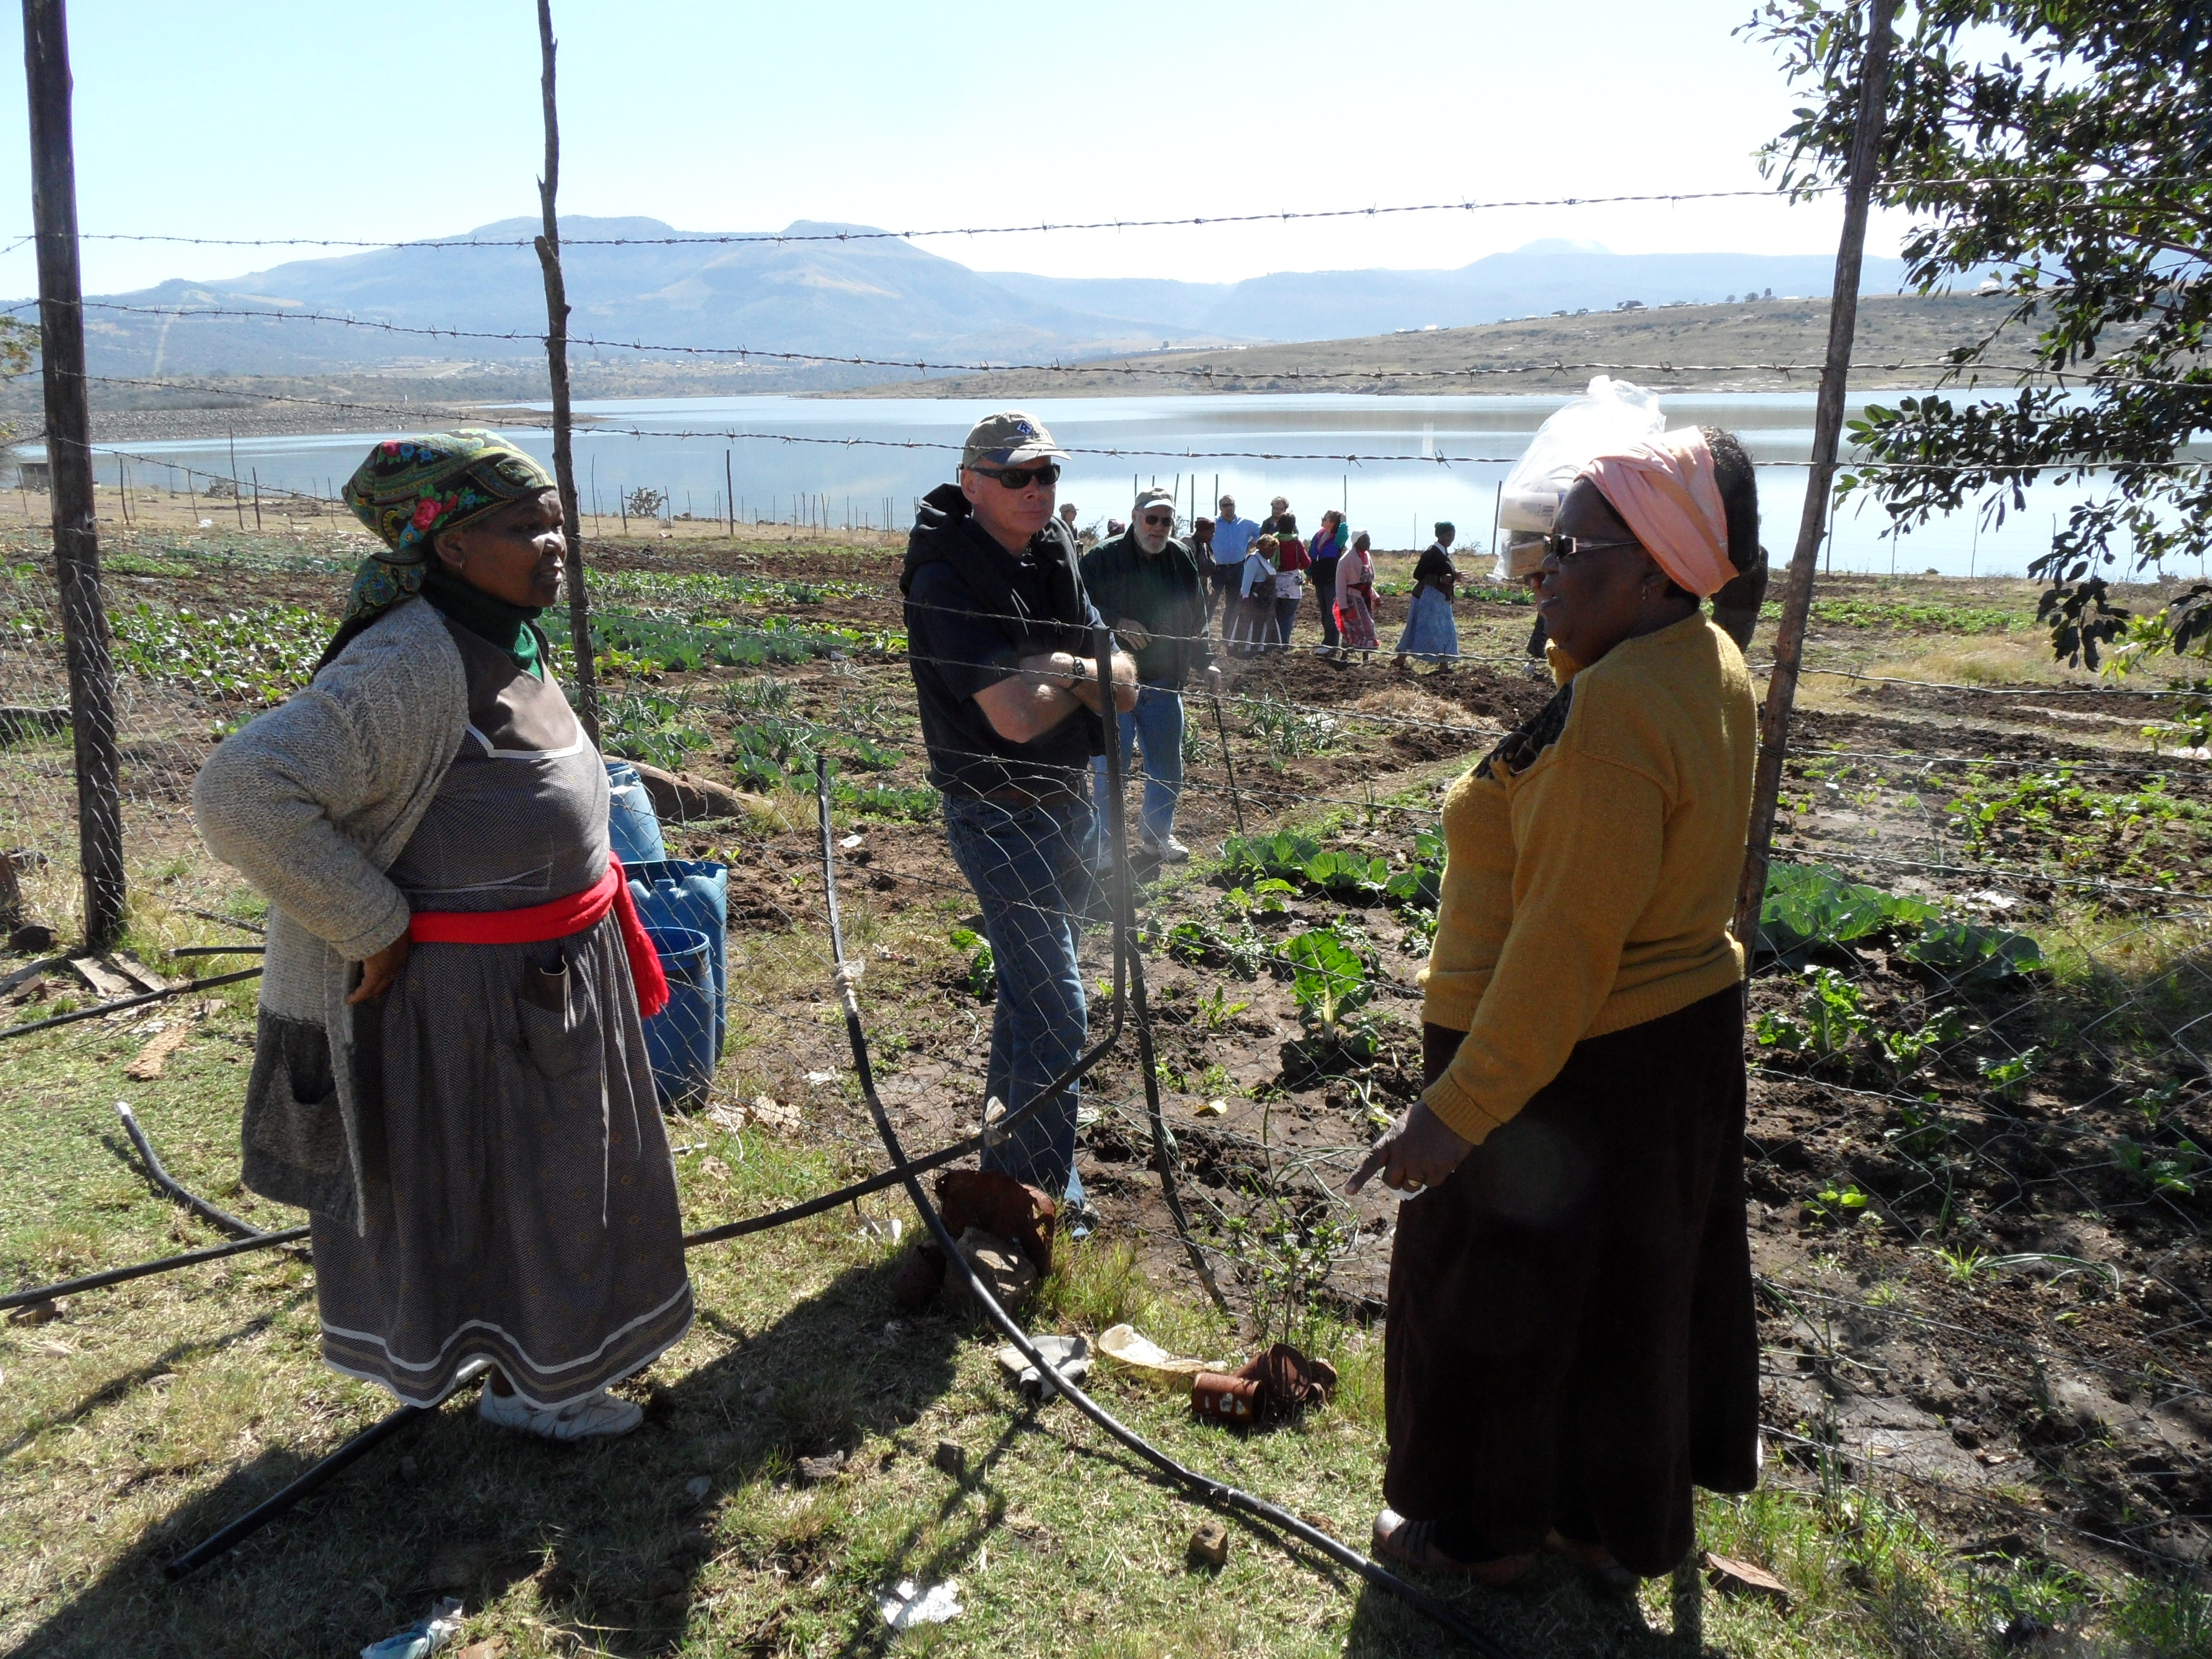
The Mazotsho Home Garden Committee is responsible for this garden:

- 24 total members; 21 are women.
- Of the 21 women, 16 are widows.
- Average age is 59; only 14 receive a pension.
- These 24 families support 115 total people; 33 are AIDS orphans.
- The 14 pensioners receive R1,080 per month old age pension, about $135. None have jobs – there are very few jobs.
- Total family income is less than $1 per day per person.

