August 12, 2014

Good morning Ed,
I wonder whether all is OK on your side and whether your plans to visit SA and the Tyume Valley later this year is still on track.

It would be lovely to see you and your group again, and learn from your rich background and wealth of experience.

We have a lovely story to tell: towards that end of last year, Vicky Riley from Tyume Valley Schools NGO approached me with a little girl, Zandile who had been born without a nose bridge and who had congenital HIV/AIDS. The viral infection was in fact the reason for the mal-development of her nose bridge. She had been teased at school endlessly, as children can often be awfully cruel.

I contacted the plastic and reconstruction surgeon in East London for a quote on the surgery, with accompanying photographs of Zandile. He was very dubious initially to speak out before he could examine her himself. Vicky took her for the appointment, and Dr. Kepler didn't charge for the initial examination and assessment. He then suggested that we go through the Smile Foundation, who provide financial assistance for cleft palate and hare lip reconstruction.

I have attached Vicky's feedback with photos of Zandile. It is so rewarding if one can be part of changing another person's life for the better, isn’t it.

All the best for now, and I am looking forward to your response as to when we can expect you here.

Warm greetings,
Norma

From: Vicky Riley
Date: 08 August 2014 at 4:52:38 PM SAST
Subject: Zandile
Dear Friends
Zandile's operation was a huge success. It took place from approx. 11:45am – 2:15pm yesterday afternoon. It ended up being a much simpler operation than originally anticipated, with no need to remove any rib or ear cartilage.
The 2 surgeons, Dr. Kepler and Dr. Van de Walt rebuilt her nose using cartilage and excess skin from her existing nose. They did not need to cut away any skin from her forehead, so there would be no scarring. She is unlikely to need any further surgery.
Her hair line on her forehead was not addressed in PE as Dr. Kepler decided it would be least invasive to use laser hair removal.
So I will need to take Zandile to EL once a month, for 5 or 6 treatments.
As things went as smooth and successful as they could, I have been able to bring Zandile and her mum home today!
It was particularly emotional when Zandile and her twin sister Zianda were reunited.
We are going to Dr. Kepler's office on Monday 18th August to have the stitches removed and so he can check the nose. It has been an extremely emotional 3 days for all involved, and taken a tremendous amount of help, support and favours all over the Eastern Cape!
So, the hugest of thanks to:
Dr. Kepler and his staff - for making this a reality
Dr. Kepler & Dr. Van de Walt - for carrying out amazing surgery as part of their Smile Foundation work
Margaret Kiloh - for planting the idea to help Zandile
Moira Gerszt (Operations Exec Director) and Tanya Jackson (Regional Coordinator. P.E.) - the Smile Foundation for accepting to fund and coordinate Zandile's surgery.
Lungi - Theatre Sister for sharing her photos with me
All the amazing Dr's, sisters, nurses and staff at the PE Provincial Hospital.
Dr. Norma - for initially meeting Zandile and referring me to Dr Kepler
Brian and Cheryl - for accommodating and feeding me
Sugne and Adam - for taking great care of my puppy for me, at such short notice
John Schenk - for lending me his bakkie while the charity bakkie is getting repaired
Fiona Lees - for being an extremely supportive ear to bend, and Zandile's new PJ's and slippers
and everyone else who has helped change this little girls life and had positive thoughts & prayers for her. She is unbelievably grateful!
More pictures to follow over time, but here are a few of the journey so far.
This is Vicky Riley, Zandile’s mom, Zandile and I presume a nurse.
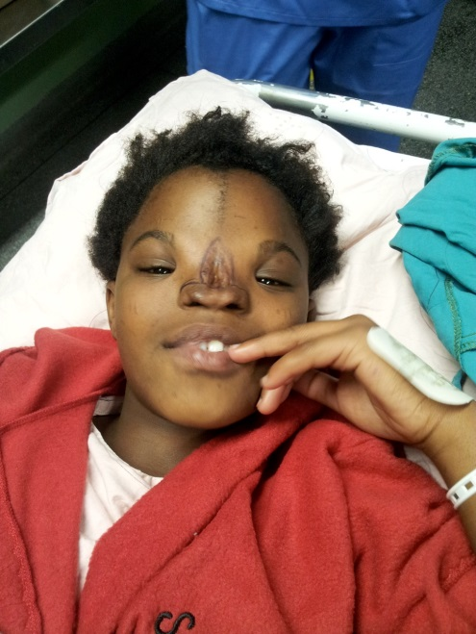
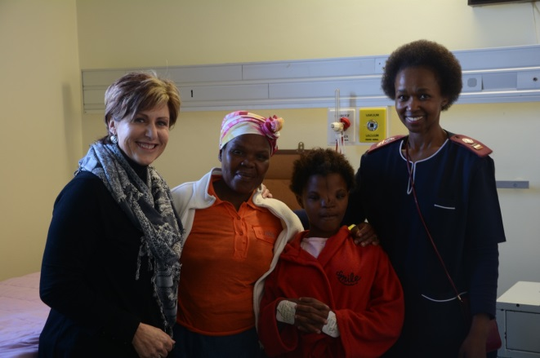

Zandile – pre-surgery

A picture of SUCCESS!
